Handling Interaction
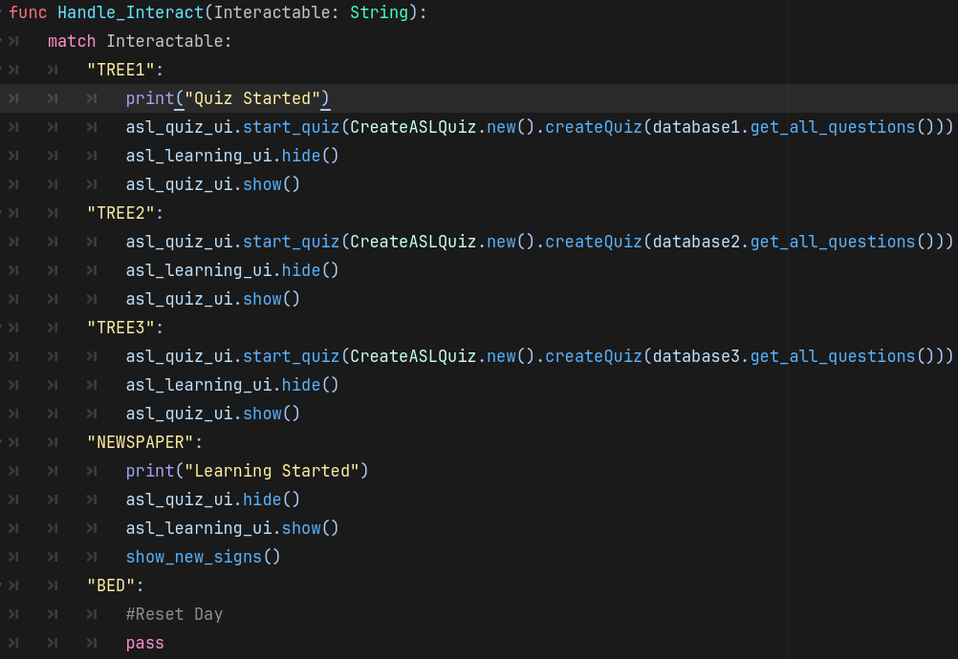
When the player presses the interact key Handle_interact is given a String that will match what object the player is interacting with.

ASL Quiz Functions
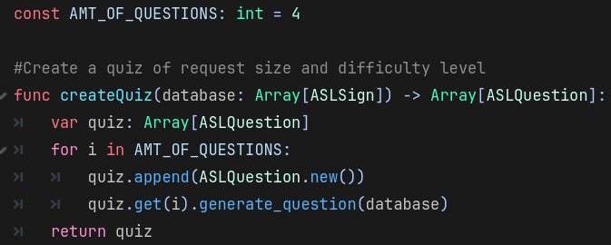
Creates an array of an object called ASLQuestion

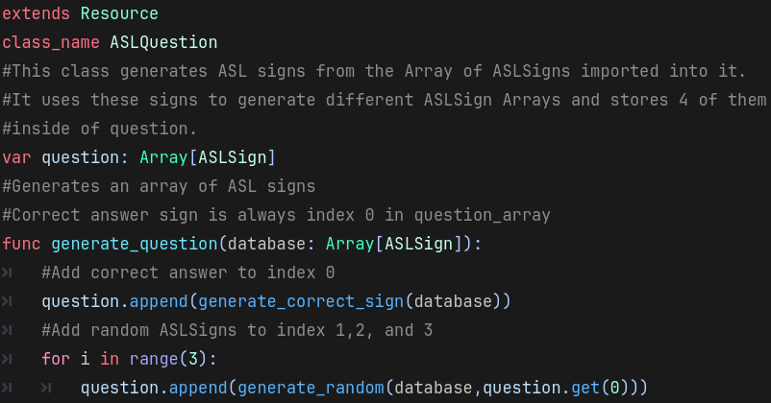
When and ASLQuestion object is created and ASLQuestion.generate_question(Array[ASLSign]) is called it sores 4 ASLSigns from the ASL Data base into question.

Resets quiz and calls function to start display the first ASLQuestion in the array given to it.
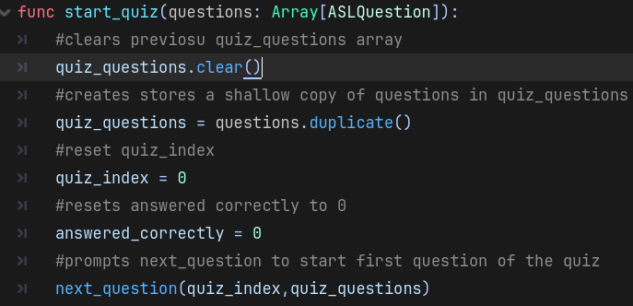

Calls a func to randomly determine the type of question displayed, also emits a signal that the game_manager uses to end the quiz and hide the UI.
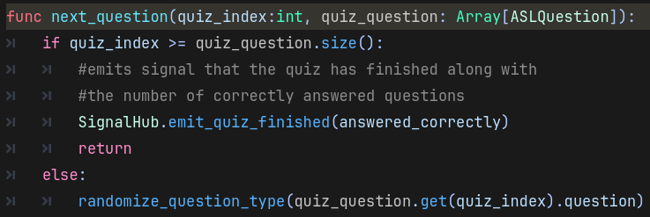
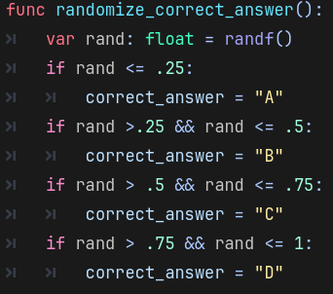
Is used to randomize which button the correct answer will be assigned to.

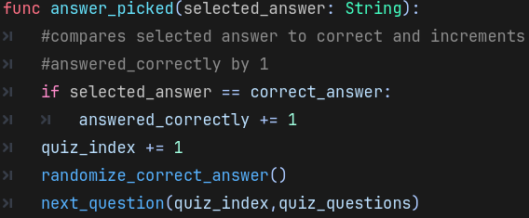
Is called when the players presses one of quiz answer buttons. It randomizes the next correct answer and calls next_question with the upated index.

ASL Learning Function
Updates UI to show new signs based on whether a data base of a certain difficulty has been fully completed or not.
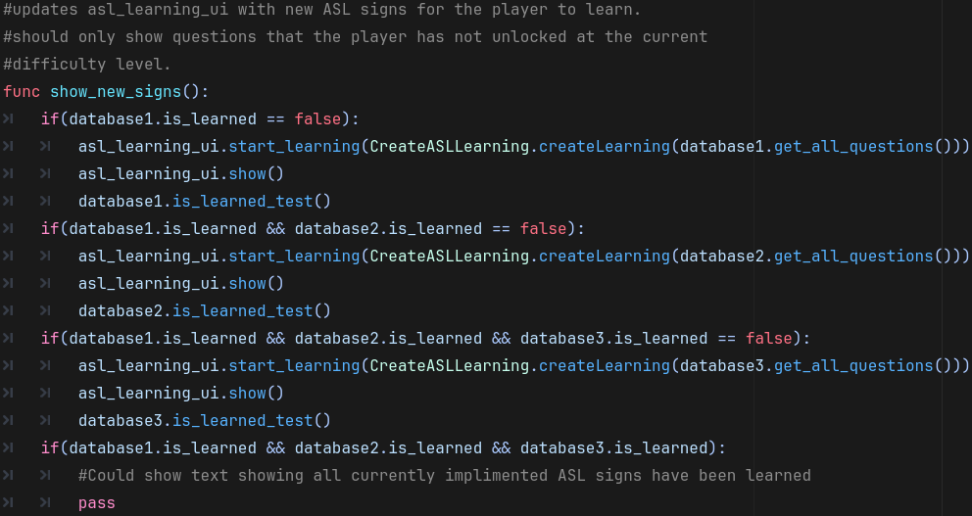
Used to create an Array of 4 ASLSigns
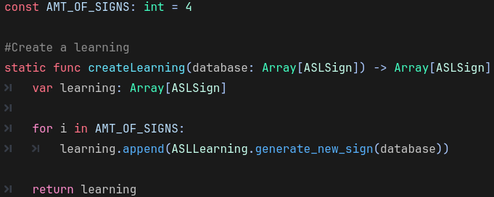

Used to retrieve an ASLsign that the player has not currently unlocked. Also, unlocks the new sign for the player.
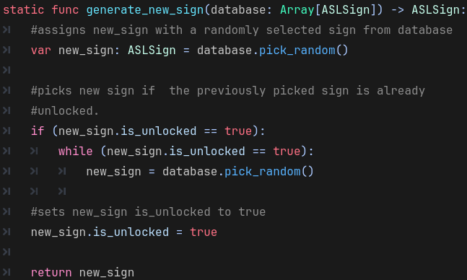
Displays new signs given to it by game_manager.
